C:\Users\salman.aziz\Desktop\curemd-142-52.png

**TFS Setup**

|  |  |
| --- | --- |
| **Prepared by:** | **Abdul Wahab & Waqas Khalid** |
| **Reviewed by:** | **Mah Rukh** |
| **Version:** | **1.0.1** |

## TFS Configuration:

Setting up Team Foundation Server:

* 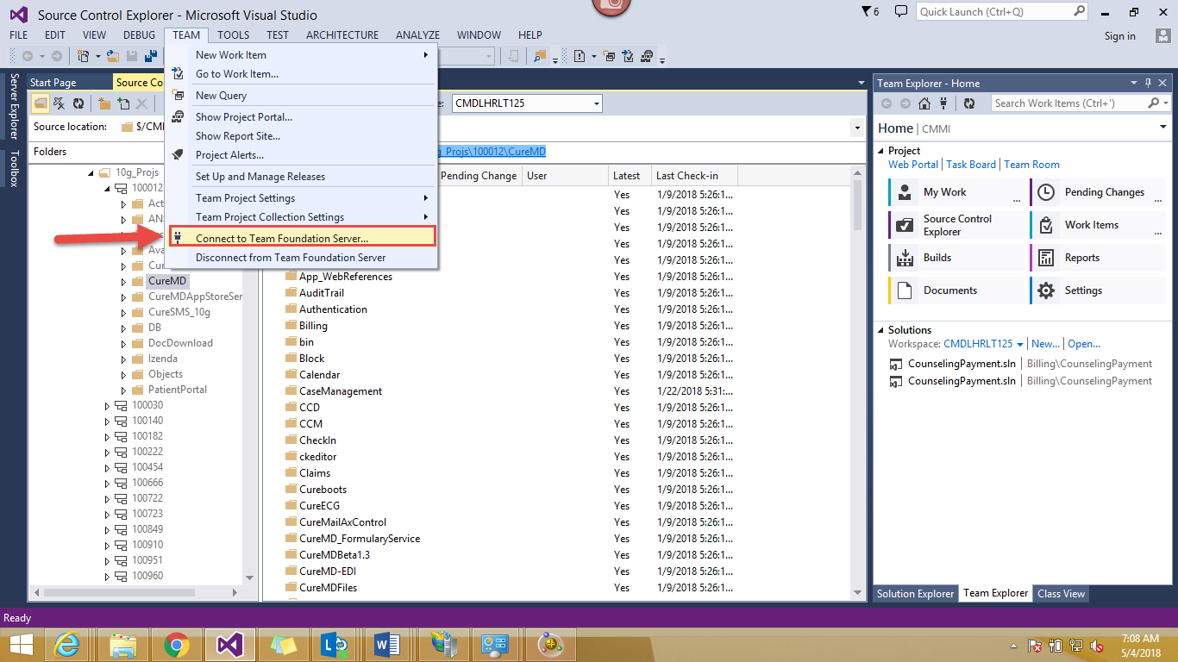Open Visual Studio 2013 in Admin Mode (Run as Administrator) and in top menu bar go to “Team” as shown in screenshot below
* In the drop down click on the option “Connect to team foundation server”
* On clicking, a window will open on right side with multiple options. Attached is the screenshot.

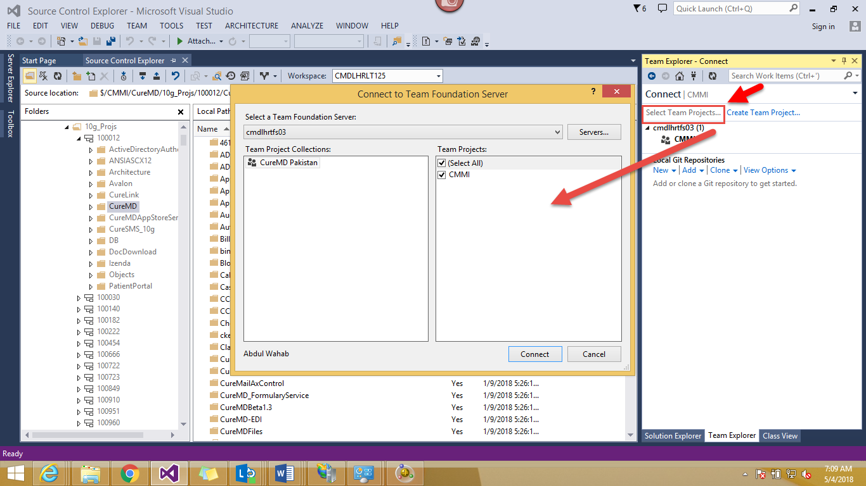

* Click on the option “Select Team Project”. A window will open. Now if you are first time user, you have to add the name of server you want to connect.

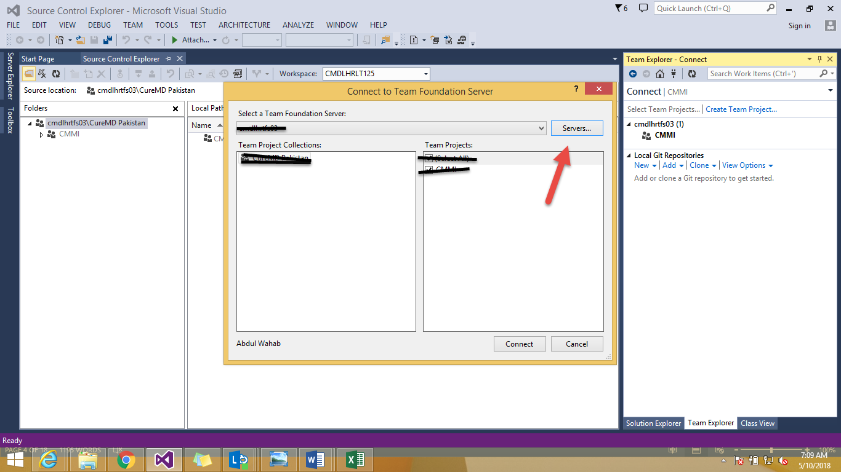

Click on “Servers” to add a server.

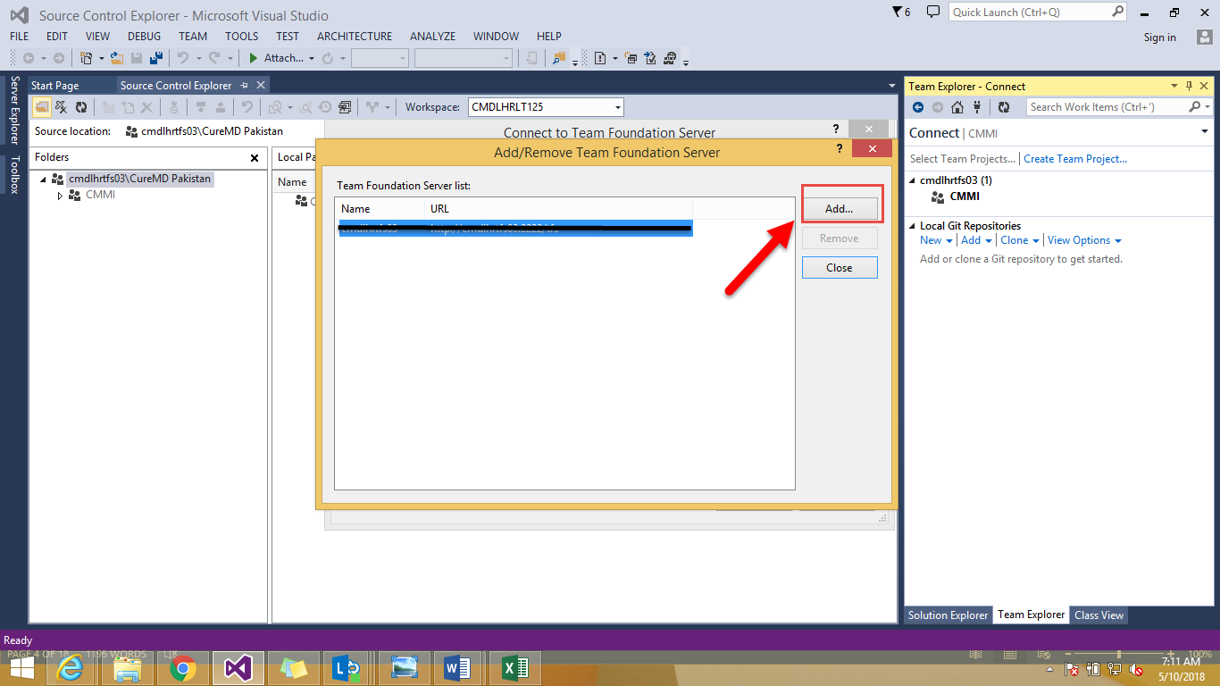

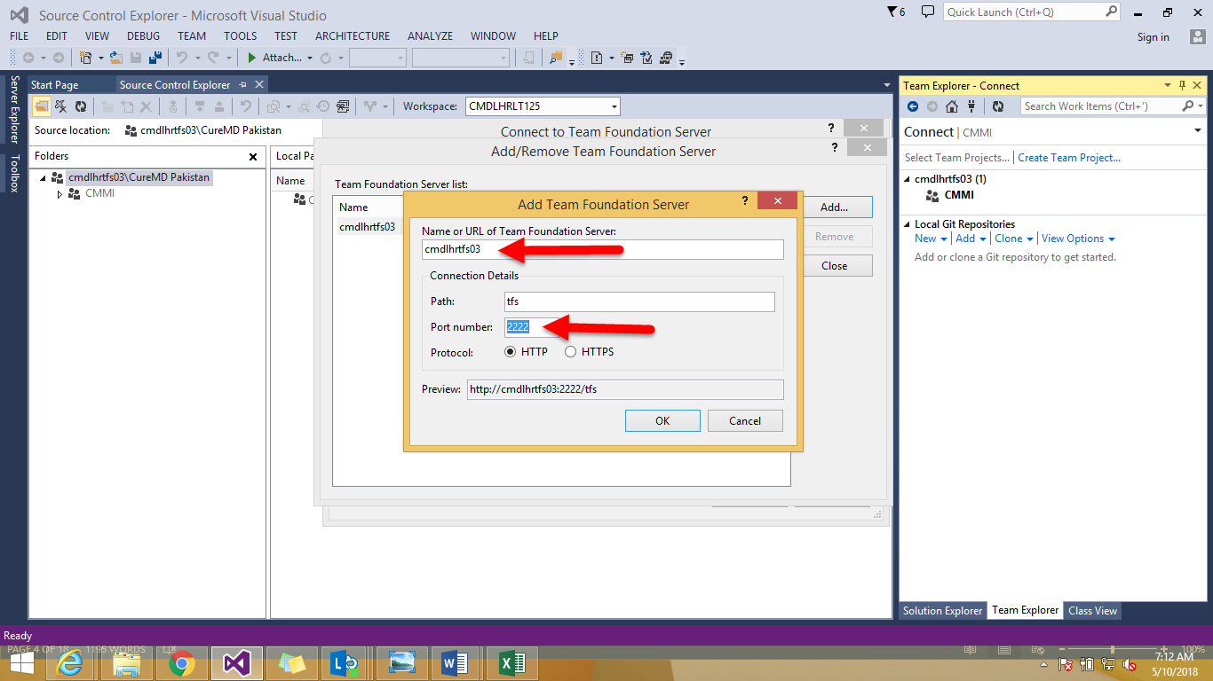

Give name “cmdlhrtfs03” and port number “2222”.



Click on “connect” button at bottom.

* 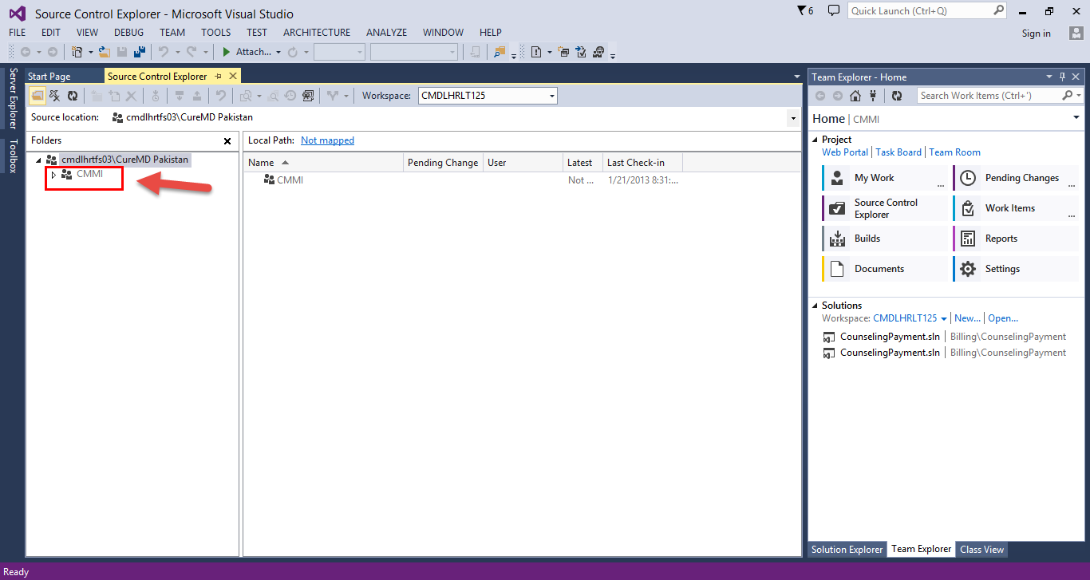After Loading you will see CMMI Option in the left menu. See Screenshot below.
* ***Configuration of TFS is done.***